

**Department of Computer Science and Engineering**

**Project Report**

Library Management system

Team Runtime Terror

**Md. Istiakul Alam (C211088)**

**Md. Minhaz Uddin (C211092)**

**Enjamamul Emrus Fahim (C211108)**

**Supervised By**

**Mohammed Mahiuddin**

**Assistant Professor Dept. of CSE, IIUC**

**DECLARATION**

**We hereby**,

Declare that the work has been done by ourself under the supervision of Mohammed Mahiuddin, Assistant Professor, Department of Computer Science & Engineering, International Islamic University Chittagong. This report or any part of this portion of the work contained in this project has been submitted in support of any application for any other degree or qualification of this or any other university or institute of learning.

**Signature of students**

**______________**

**Md. Istiakul Alam (C211088)**

**______________**

**Md. Minhaz Uddin (C211092)**

**______________**

**Enjamamul Emrus Fahim (C211108)**

**List of Figure**

Figure 1.1: Login Page.

Figure 2.1: Logged In As Admin

Figure 2.2: Add Librarian.

Figure 2.3: Delete Librarian.

Figure 3.1: Logged In as Librarian.

Figure 3.2: Student Menu.

Figure 3.3: Book Menu.

Figure 4.1: Add Student.

Figure 4.2: Update Student.

Figure 4.3: Delete Student.

Figure 4.4: View Student.

Figure 5.1: Add Book Details.

Figure 5.2: Update Book Details.

Figure 5.3: Delete Book Details.

Figure 5.4: View Book Details.

Figure 5.6: Issued Book.

Figure 5.7: Return Book.

**Project Objective:**

The main objective of the Python Project on Library Management System is to manage the details of Member, Books, Student, Issues, Address. It manages all the information about Member, Librarian, Address, Member. The project is totally built at the administrative end and thus only the administrator is guaranteed access.

* Develop a system that can replace the manual library management system.
* Develop a database which stores user details & book details.
* Give reliable search facility for the users.
* Administrator or librarian should have logins.

**Introduction:**

Library Management System is a system which maintains the information about the books present in the library, their authors, the members of library to whom books are issued. This is very difficult to organise manually. Maintenance of all this information manually is a very complex task. Owing to the advancement of technology, the organisation of the Book shop system becomes much simpler. The book shop Management has been designed to computerise and automate the operations performed over the information about the members, book issues and returns and all other operations. It reduces the workload of management as most of the manual work done is reduced.

**Project Profile:**

* Language: Python
* GUI: Tkinter
* Database: MySQL
* Followed: IIUC Central Library System

**Function Implemented:**

* **Login**
  + Login as Admin
  + Login as Librarian
* **Login as Admin**
  + Add Librarian
  + Delete Librarian
* **Login as Librarian**
  + Book Menu
  + Student Menu
* **Book Menu**
  + Add Book Details
  + Edit Book Details
  + Delete Book Details
  + View Book List
  + Issue Book
  + Return Book
  + Exit
* **Student Menu**
  + Add Student Details
  + Edit Student Details
  + Delete Student Details
  + View Student List
  + Exit

**Data Base Table**

|  |
| --- |
| *Admin* |
| User Name |
| Password |

|  |
| --- |
| *Librarian* |
| Full Name |
| User Name |
| Password |

|  |
| --- |
| *Books* |
| Book ID |
| Title |
| Author |
| Publisher |
| Generation |
| Status |

|  |
| --- |
| Books Issued |
| Book ID |
| Issue to |

|  |
| --- |
| Students |
| Student Id |
| Student Name |

**Data Base Model**

|  |
| --- |
| *Admin* |
| User Name |
| Password |

|  |
| --- |
| *Librarian* |
| Full Name |
| User Name |
| Password |

|  |
| --- |
| *Books* |
| Book ID |
| Title |
| Author |
| Publisher |
| Generation |
| Status |

|  |
| --- |
| Books Issued |
| Book ID |
| Issue to |

|  |
| --- |
| Students |
| Student Id |
| Student Name |

**Characteristics:**

**Admin:**

The admin login will require the librarian their username and password to have the main access to the system and secure every information ang transaction done in the system.

**Librarian:**

A librarian can manage the Book menu & Student menu.

* **Book Menu:**

This panel allows librarians to Add Book Details, Edit Book Details, Delete Book Details, View Book List, Issue Book, Return Book to a library management system application. Information such as the name of the book, name of the author and number of copies should be provided, and the data is stored in a database.

* **Student Menu:**

This panel allows librarians to Add Student Details, Edit Student Details, Delete Students Details, View Students List to a library management system application.

**Features List**

***Login Page:***

This feature used by the user to login into system. They are required to enter user id and password before they are allowed to enter the system. The user id and password will be verified and if invalid id is there user is allowed to not enter the system. User has to select between “ Log in as Admin Option” and

“Log in as Librarian Option”. If he or She selects “Log in as Admin Option”, he or she will be logged in as Admin. And If He or She selects “Log in as Librarian Option”, he or she will be logged in as Librarian.

Functional requirements

-The system must only allow user with valid id and password to enter the system

-The system performs authorization process which decides what user level can access to.

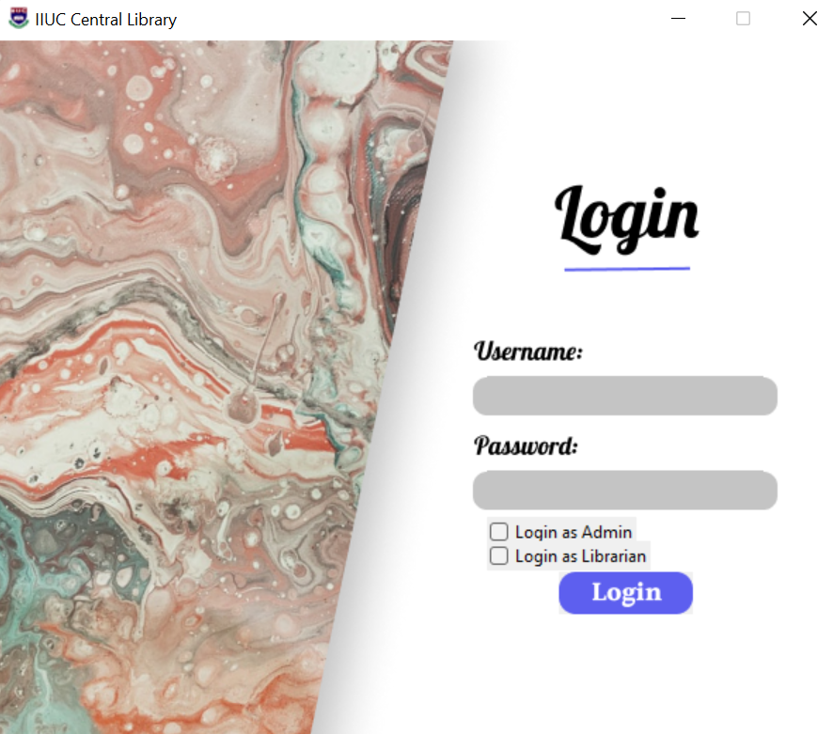

*Figure:1.1*

***LOGGED IN AS ADMIN*:**

This feature used by the admin after logged in. In this feature He can choose among 3 Options;

1.Add Librarian. (After selecting it, he can add librarian)

2.Delete Librarian. (After selecting it, he can Delete librarian)

3.Exit. (After selecting it, he can exit the software)

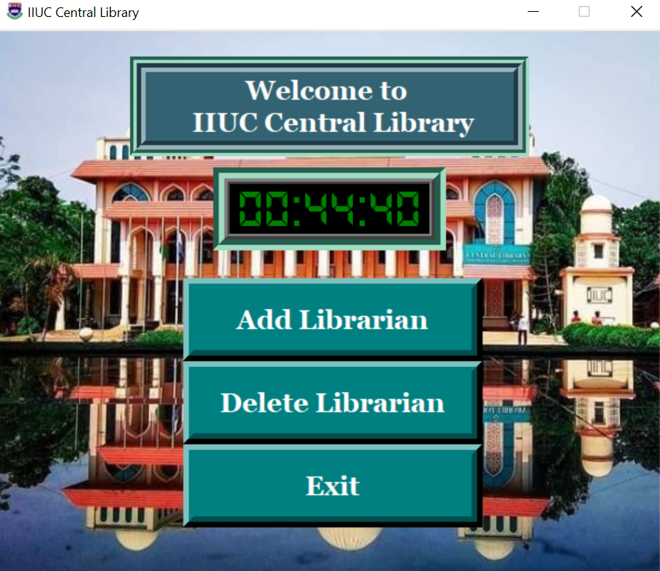

*Figure: 2.1*

* **Add Librarian:**

This feature used by the Admin after logged in. In this feature He has to fulfil 3 informatation about New Librarian,

1.Full Name. (Admin has to type New Librarian’s Full name.)

2.User Name. (Admin has to type New Librarian’s User name. A Librarian can log in as Librarian if he uses this User Name.)

3.Password:(Admin has to type New Librarian’s Password. A Librarian can log in as Librarian if he uses this Password.)

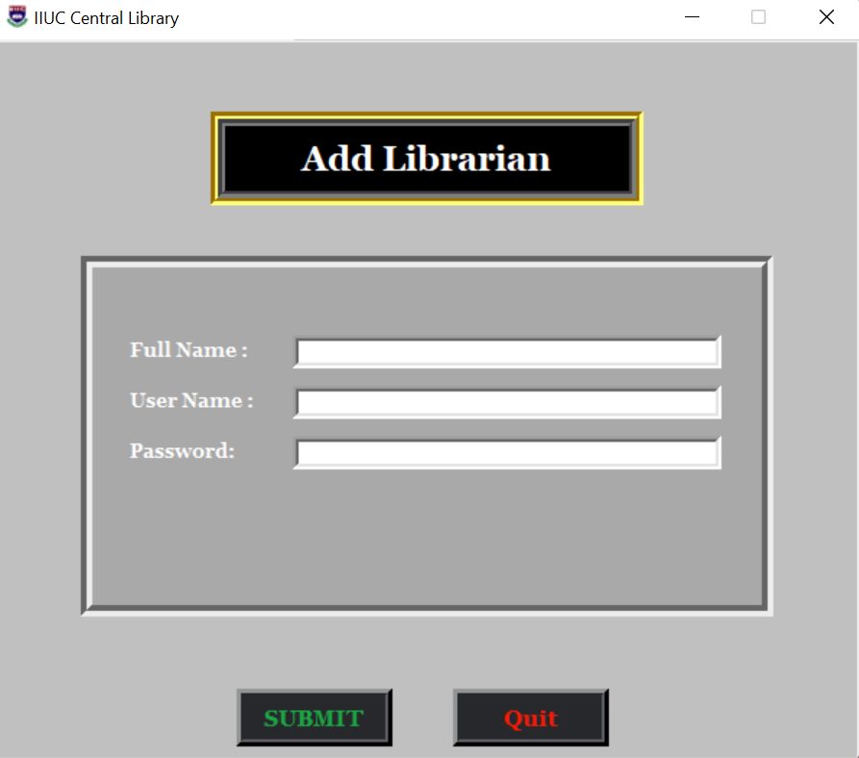

Figure: 2.2

* **Delete Librarian:**

This feature used by the admin after logged in. In this feature, He has to fulfil Librarian’s User Name, Then He has to select button.

If this user name is found in the Librarian’s name, Libarian’s information will be shown. Then Admin can Delete Librarian by Using Delete button.

If this user name is not found in the Librarian’s name, libarian’s information will not be shown. Then Admin cannot Delete Librarian.

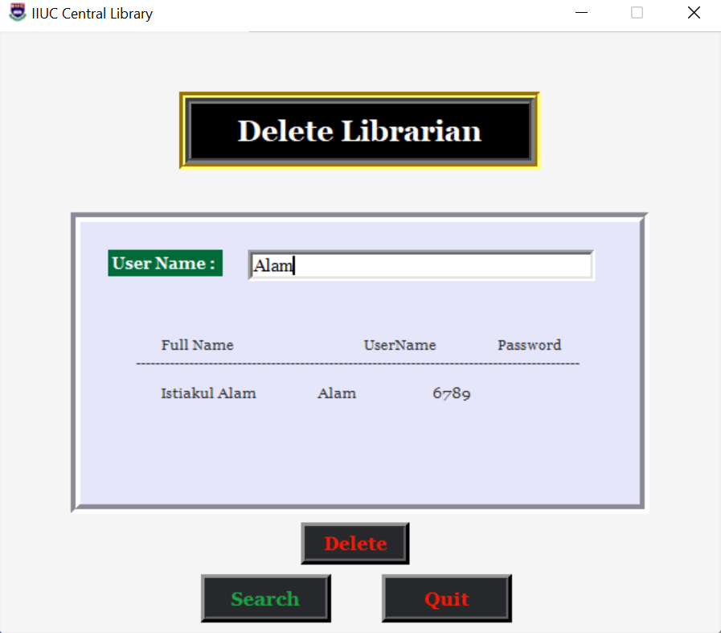

Figure: 2.3

***LOGGED IN AS LIBRARIAN:***

This feature used by the Librarian after logged in. In this feature He can choose among 3 Options;

1. Book Menu. (After selecting it, he/she can work in book menu)

2.Student Menu. (After selecting it, he/she can work in student menu)

3.Exit. (After selecting it, he/she can exit the software)

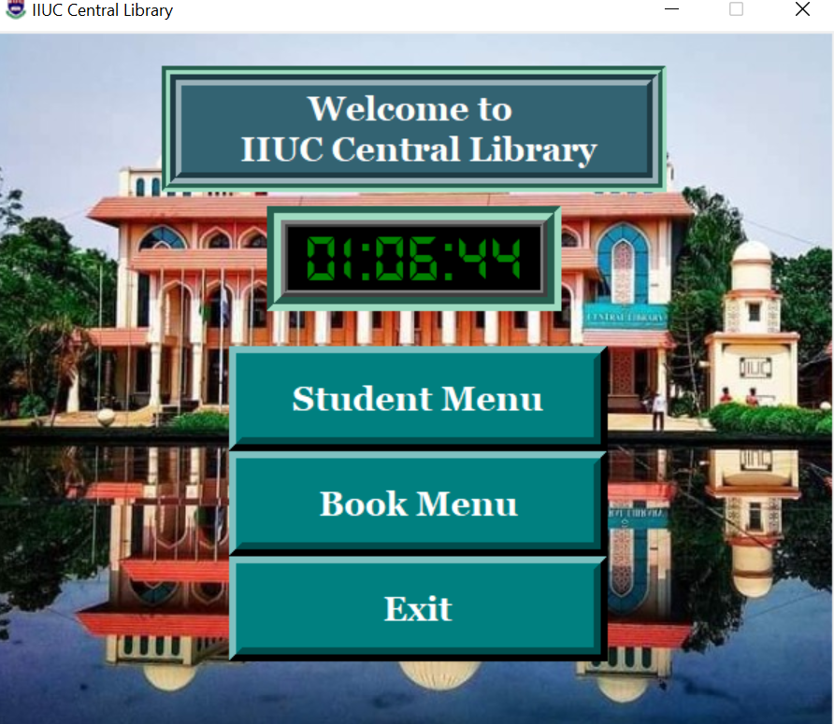

*Figure: 3.1*

**STUDENT MENU:**

This feature used by the Librarian after selecting Student Menu Option. In this feature He can choose among 5 Options;

1.Add Student. (After selecting it, he can add student)

2.Edit Student. (After selecting it, he can edit student information)

3.Delete Student. (After selecting it, he can delete student)

4.View Student. (After selecting it, he can view student list)

5.Exit. (After selecting it, he can exit the software)

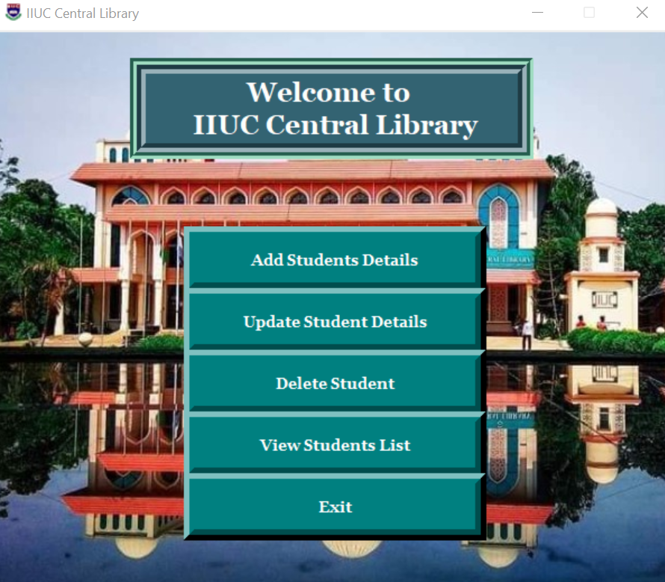

Figure: 3.2

* **Add Student:**

This feature used by the Librarian after logged in. In this feature He has to fulfill 2 information about New Student,

1.Student ID. (Librarian has to type new Student’s ID.)

2.Full Name. (Librarian has to type new Student’s Full name.)

After that Librarian has to select Submit button.

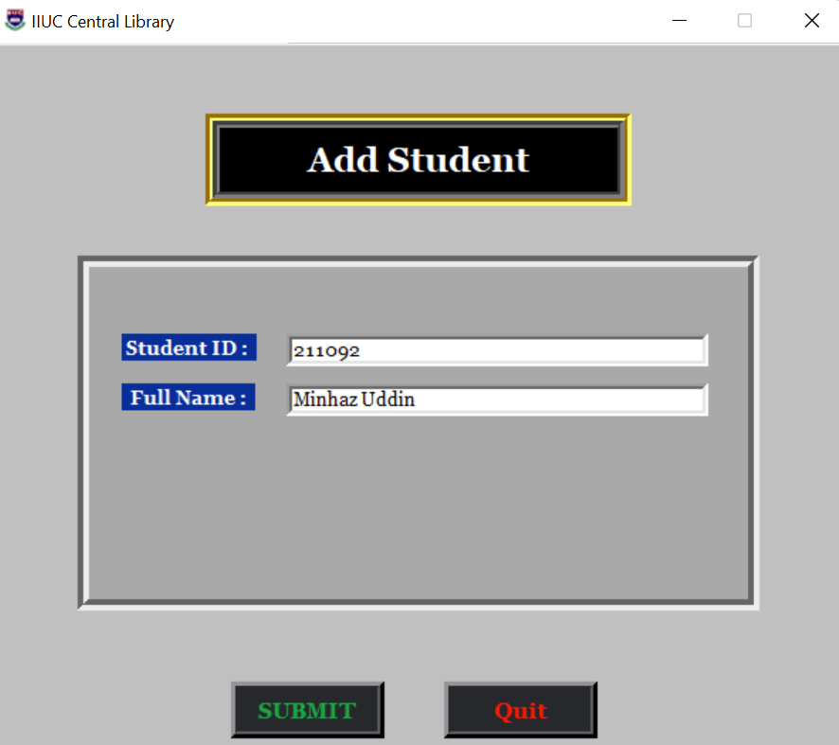

*Figure: 4.1*

* **Update Student:**

This feature used by the Librarian after logged in. In this feature He has to fulfill Student ID. Then He has to select search button.

If this student id is found in the Student’s ID list, Student’s information will be shown. Then Librarian can edit Student’s Id or Student’s Name and select submit button.

If this student id is not found in the Student’s ID list, Student’s information will not be shown. Then Librarian cannot Edit Student’s Information.

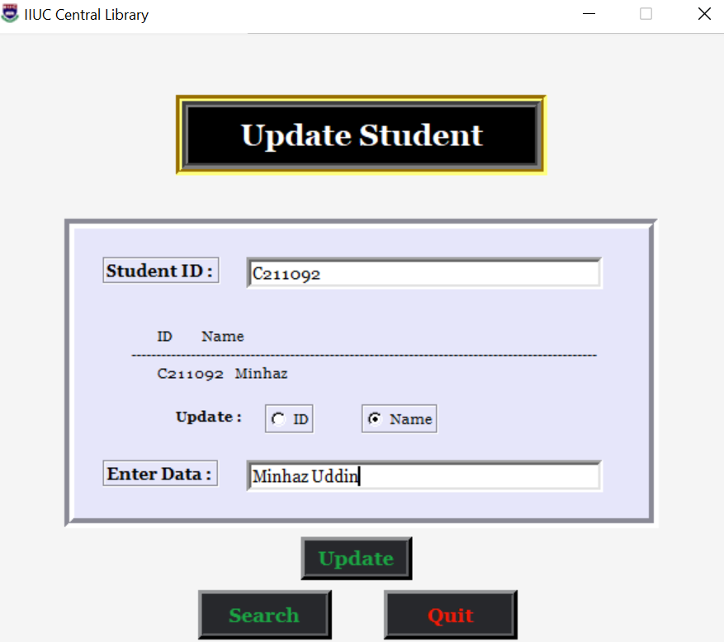

*Figure: 4.2*

* **Delete Student:**

This feature used by the Librarian after logged in. In this feature, He has to fulfill Student’s Student ID., Then He has to select search button.

If this student id is found in the Student’s ID list, Student’s information will be shown. Then Librarian can Delete Student by Using Delete button.

If this student id is not found in the Student’s ID list, Student’s information will not be shown. Then Librarian cannot Delete Student.

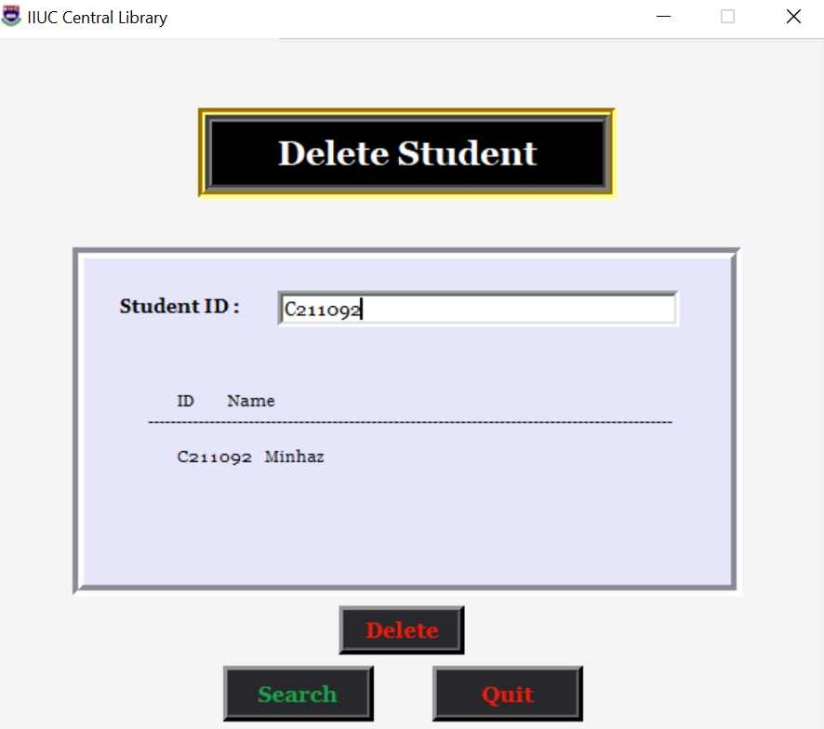

*Figure: 4.3*

* **View Student*:***

This feature used by the Librarian after logged in. In this feature He can see Student’s list where Student’s Id list and Student’s Name list will be shown.

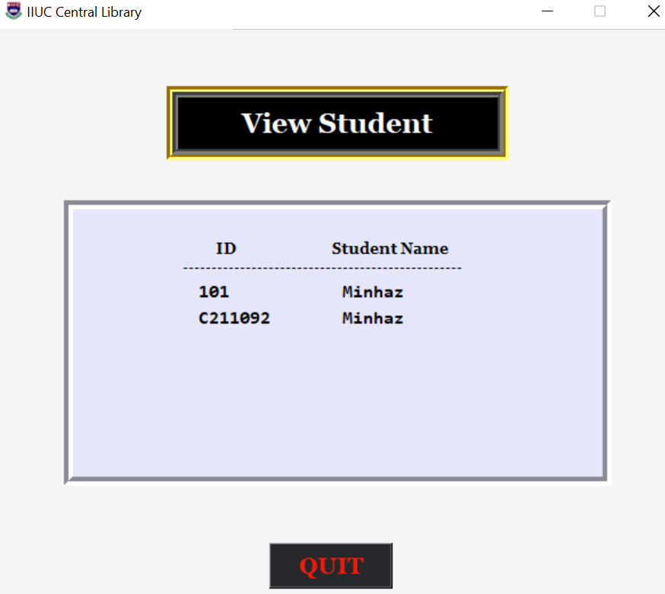

*Figure: 4.5*

***BOOK MENU:***

This feature used by the Librarian after selecting Book Menu Option. In this feature He can choose among 5 Options;

1.Add Book. (After selecting it, he can add book)

2.Edit Book. (After selecting it, he can edit book information)

3.Delete Book. (After selecting it, he can delete book)

4.View Book. (After selecting it, he can view book list)

5.Issue Book. (After selecting it, he can issue book)

6.Return Book. (After selecting it, he can return book)

7.Exit. (After selecting it, he can exit the software)

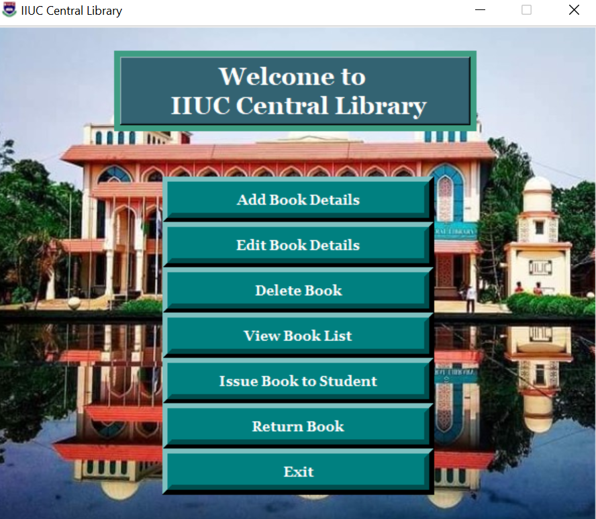

*Figure: 3.3*

* **Add Book:**

This feature used by the Librarian after logged in. In this feature He has to fulfill 6 information about New Book,

1.Book ID. (Librarian has to type.)

2.Title. (Librarian has to type.)

3.Author. (Librarian has to type.)

4.Genre. (Librarian has to type.)

5.Publisher. (Librarian has to type.).

6.Status. (Librarian has to type.)

After that Librarian has to select Submit button.

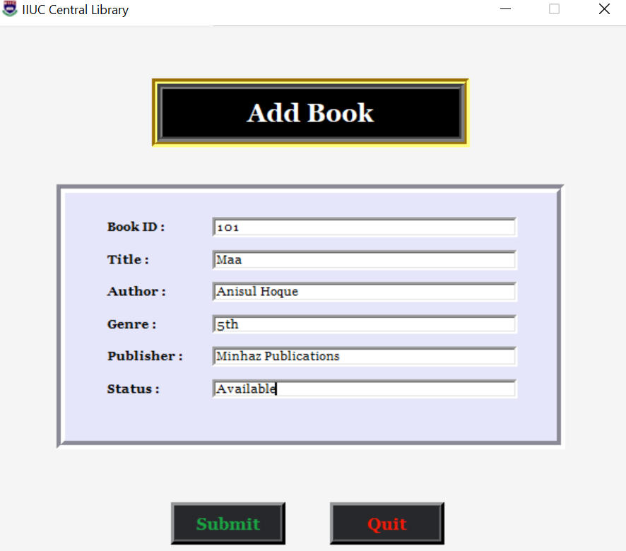

*Figure: 5.1*

* **Update Book:**

This feature used by the Librarian after logged in. In this feature He has to fulfill Book ID. Then He has to select search button.

If this Book id is found in the Book’s ID list, Bookts information will be shown. Then Librarian can edit Book’s Id or Title or Author, and select submit button.

If this book id is not found in the Book’s ID list, Book’s information will not be shown. Then Librarian cannot Edit Book’s Information.

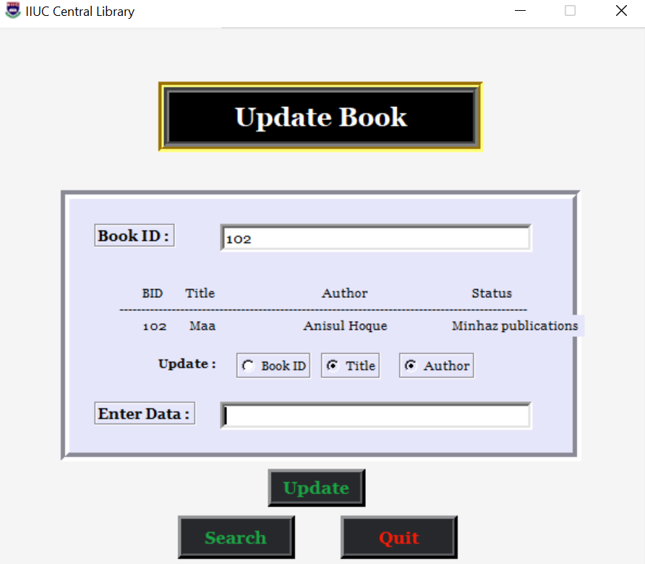

*Figure: 5.2*

* **Delete Book:**

This feature used by the Librarian after logged in. In this feature, He has to fulfill Student’s Book ID., Then He has to select search button.

If this student id is found in the Book’s ID list, Book’s information will be shown. Then Librarian can delete Book by Using Delete button.

If this Book id is not found in the Book’s ID list, Book’s information will not be shown. Then Librarian cannot Delete Book.

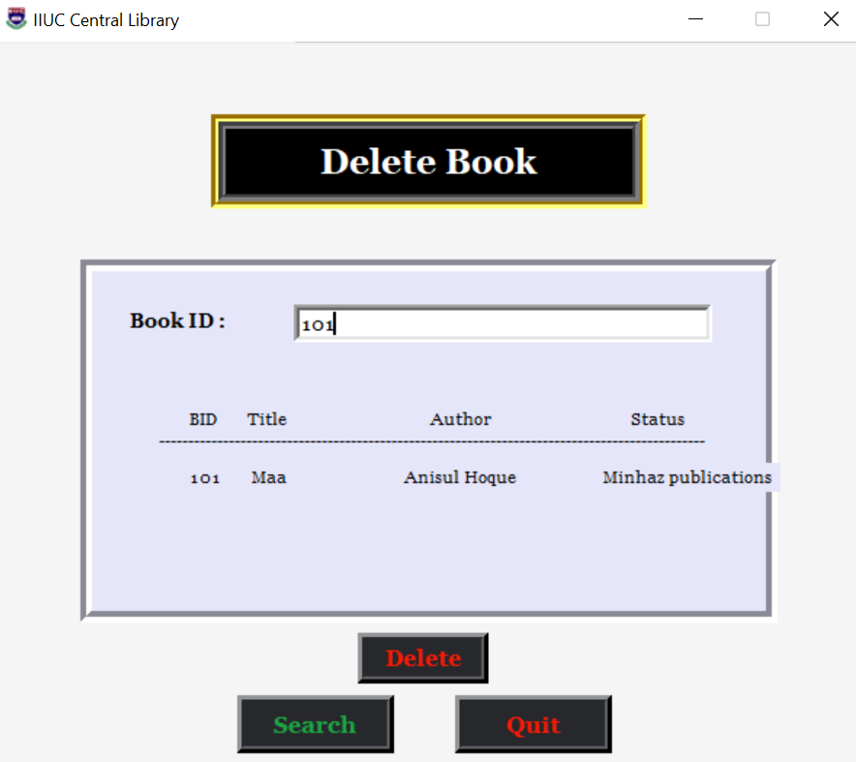

*Figure: 5.3*

* **View Book:**

This feature used by the Librarian after logged in. In this feature He can see Book’s list where Book’s Id list, Titles, Authors, Publishers, Genre and Status will be shown.

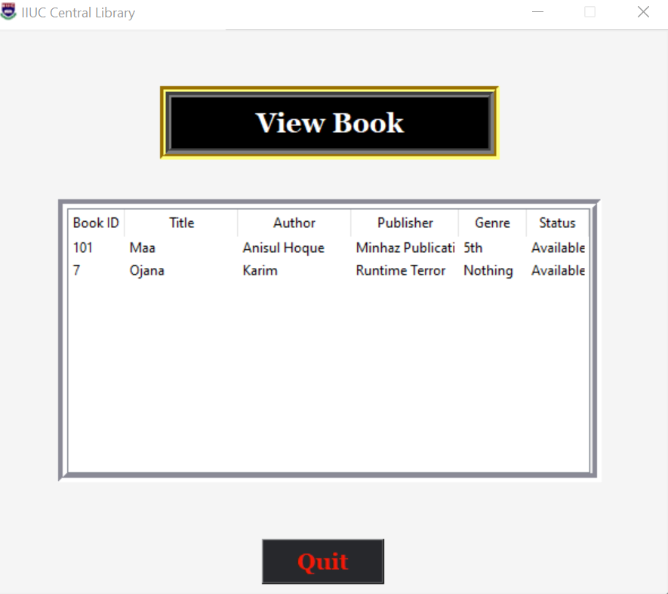

*Figure: 5.4*

* **Issue Book:**

This feature used by the Librarian after logged in. In this feature He can issue book to any student by selecting student id and book id.

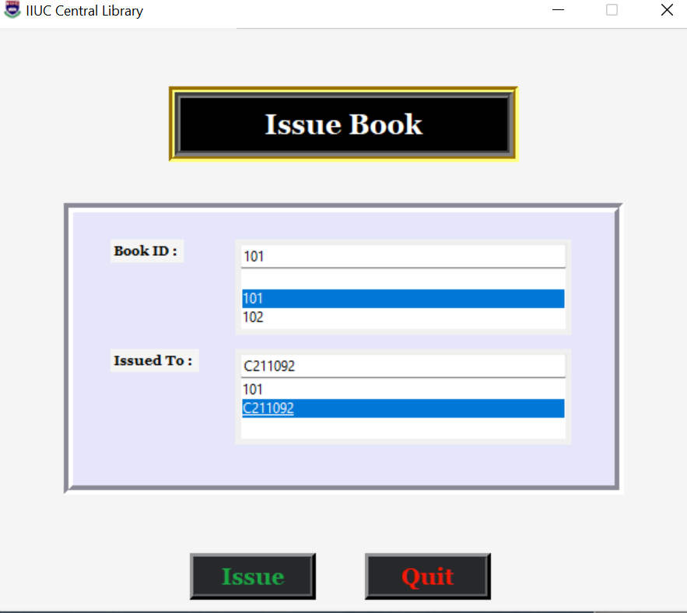

*Figure: 5.5*

* **Return Book:**

This feature used by the Librarian after logged in. In this feature He can return book to any student by selecting student id and book id.

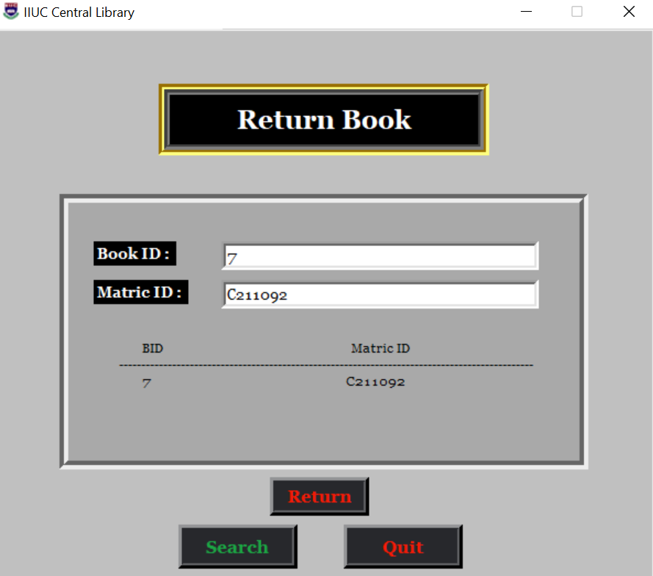

*Figure: 5.6*

**Conclusion:**

In this application we can entry a new book which has a specific Id, Book name, Author. We also add a student’s information such as Name, Id which helps librarian when a student issues a book & return a book. If librarian wants to see the details information of returning or issuing a book with date, he needs to click just a button on our application.

**END**